- Connect cables to power supplies
  - 3x 4139 cables, 1x 4163 cable
- Connect 2 HMC sig gens
- Connect the RF connections as follows in the diagram
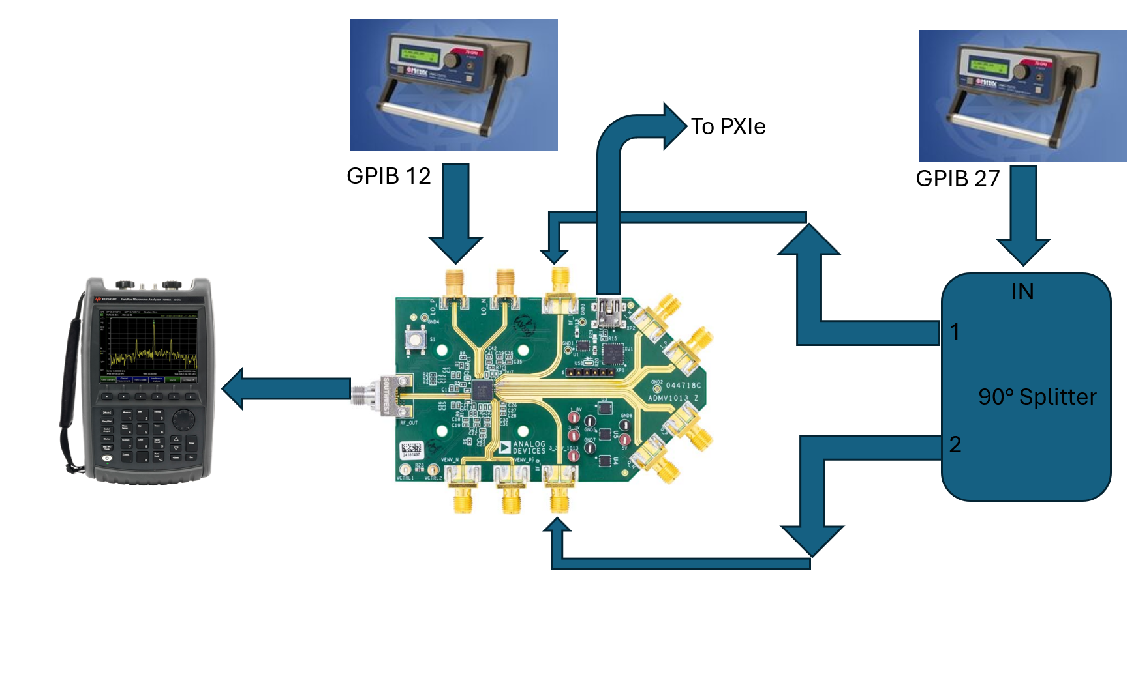
- Connect the banana jacks as follows
- Be sure to connect all ground connections together. There should be one for each card and the DUT ground (3x 4139, 1x DUT).
Black GND | GND connections
5v | 4 VCC (4139 card)
3.3 | 5 VCC (4139 card)
1.8v | 6 VCC (4139 card)
VCTRL1 | CH0 (4163 card)
- Open the Labview software
  - Configure the Data block as necessary
- Open the power block
Be sure to activate all channels and queue the changes
  - Slot_4
    - Voltage = 5v, channel name = 5v
  - Slot_5
    - Voltage = 3.3v, channel name = 3.3v
  - Slot_6
    - Voltage = 1.8v, channel name = 1.8v
  - CH0 (4163 card)
    - Voltage = 1.8v, channel name = 1.8v VCTRL
- Open the RF Block
  - GPIB 27
    - Name = IF, Freq = 1GHz, Power = -10dBm,
  - GPIB 12
    - Name = LO, Freq = 7GHz, Power = 0dBm
- Check unconfigured Supply Currents
- Note! If the part is pre-configured this could be different, see the configured supply currents if this doesn’t match.
5v | 3.3v | 1.8v
~15mA | ~380mA | ~3mA

- Open part in ACE. Confirm that the VCTRL voltage will be 1800mV, this is the default value so there should be nothing necessary to do here. Configure the block diagram of the part to match the following picture. The only changes from default should be the LO mode select (SE_Mode_N_Side_Disable) and the LO Freq BW (6.6GHz to 9.2GHz)
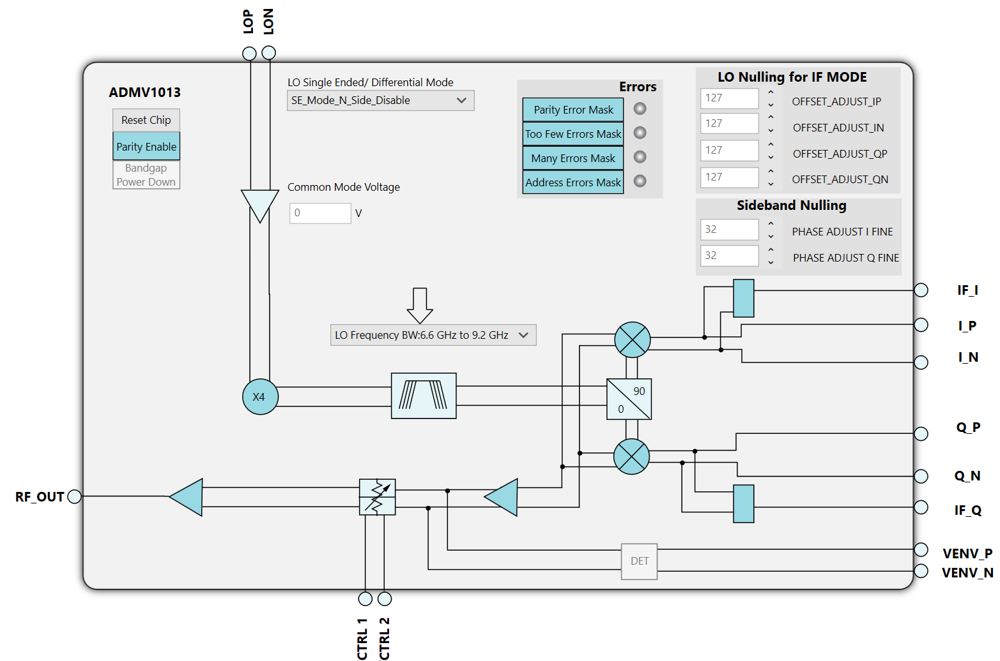

- Note the configured Supply Currents
5v | 3.3v | 1.8v
~20mA | ~555mA | ~2mA
- Ensure a tone is visible at 27/29 GHz, either can be visible. Fine if both are visible.
- Open the python script at the file path C:\Git\Rad-Effects-Test-Software\Python Scripts\ADMV
- Run the python script and click record data toggle in labview

